**ATOMIC SPECTRA AND FLAME TEST**

**OBJECTIVES:**

1. **Explain how the transition of electrons between energy levels can produce atomic absorption and emission line spectra.**
2. **Describe and explain how flame tests and atomic absorption spectroscopy (AAS) can be used to identify elements.**
3. ***Conduct experimental work safely, competently and methodically, including flame tests. (SIS)***

Bohr’s model of the hydrogen atom gave an exact explanation for its observed emission spectrum:

* Electrons exist in discrete energy levels – they cannot have intermediate energies.
* A photon can be emitted (electron returns to a ground state back to lower energy level)- or absorbed (electron promoted to a higher energy level) when an electron moves between energy levels.
* The energy of the photon corresponds to the difference between energy levels (ΔE)
* Energy shells are closer to nucleus are lower in energy.

Bohr’s theory was able to explain the hydrogen spectrum, but it failed to account for the lines observed in the atomic spectra of atoms containing more than one electron.

Spectra can be simplified to one of the three basic types. Simple examples in the visible waveband are shown below:

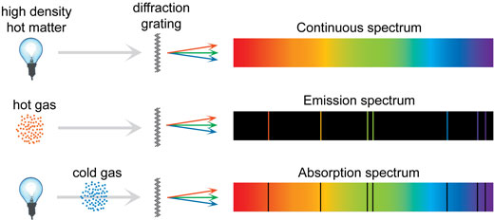

**CONTINUOUS SPECTRUM** can be produced by thermal emission from a black body.

**EMISSION SPECTRA** (line spectra) have discrete bright lines (lines of light emitted) on a black background.

Emission spectra refers to the range of wavelengths emitted by an atom stimulated by either heat or electric current. For each particular element wavelengths of light match the absorption spectrum lines exactly.

**ABSORPTION SPECTRA** have black lines on bright background.

The spectrum formed by electromagnetic radiation that has passed through a medium in which radiation of certain frequencies is absorbed.

Each element has its own unique line spectrum and thus referred to as the “fingerprint” for a particular element.

**Question:**

What does an element’s absorption or emission spectrum tell us about the arrangement of electrons in atom?

**Answer:**

Electrons are only found in discrete energy levels. Wavelength of spectral lines tells us the difference in energy between energy levels.

**FLAME TEST**

A flame test can be used to identify a range of metal ions due to the characteristic colours produced when their salts are burnt. When atoms are heated, they absorb the specific energies needed for their electrons to jump up to a higher energy levels. Now, the atom is in an “excited” state, which is unstable. Since the electrons prefer to be closer to the nucleus, they quickly return to lower energy level and energy in a form of light is emitted.

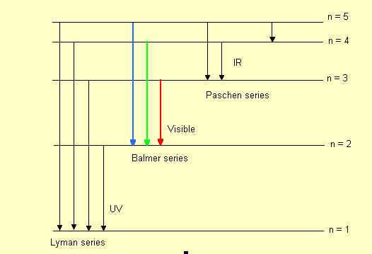

A small amount of salt being tested placed on platinum wire and burnt in a very hot non-luminous Bunsen flame. Typical flame colours are:

|  |  |
| --- | --- |
| Sodium | Yellow |
| Barium | Pale green |
| Copper | Blue/green |
| Calcium | Orange/red |

These characteristic colours arise because electrons in atoms of a particular element occupy definite energy levels and emit particular frequencies when they jump from higher to lower energy level.

**Limitations of flame test:**

* Only small number of metal ions can be distinguished in this way as Bunsen flame is not hot enough to excite the electrons of many atoms.
* It is difficult to distinguish between very similar colours. (random error)
* The colours may also be affected by the presence of traces of other ions.

**Questions**

1. What is meant by the term “ground state” of an atom?

No electrons are energized.

1. How is an excited atom produced?

An electron absorbs energy and moves to a higher energy level.

1. How does Bohr’s model of the hydrogen atom explain the emission spectrum of hydrogen?

It highlights how electrons reside in set energy levels and how a change in energy of an excited electron from a higher to a lower energy level emits a photon with a particular frequency. This frequency corresponds with a colour that is emitted.

1. Explain why strontium and barium compounds produce different colours in a flame test.

They produce different frequencies when their excited electrons move to a ground state. These frequencies make up the colour that is observed during a flame test.

1. Potassium chloride is sometimes used as a salt substitute in cooking. How could a sample of sodium chloride be distinguished from potassium chloride?

Potassium chloride will produce a purple flame if heated as opposed to an orangey-yellow flame produced by sodium chloride. This is due to their emission spectrum.